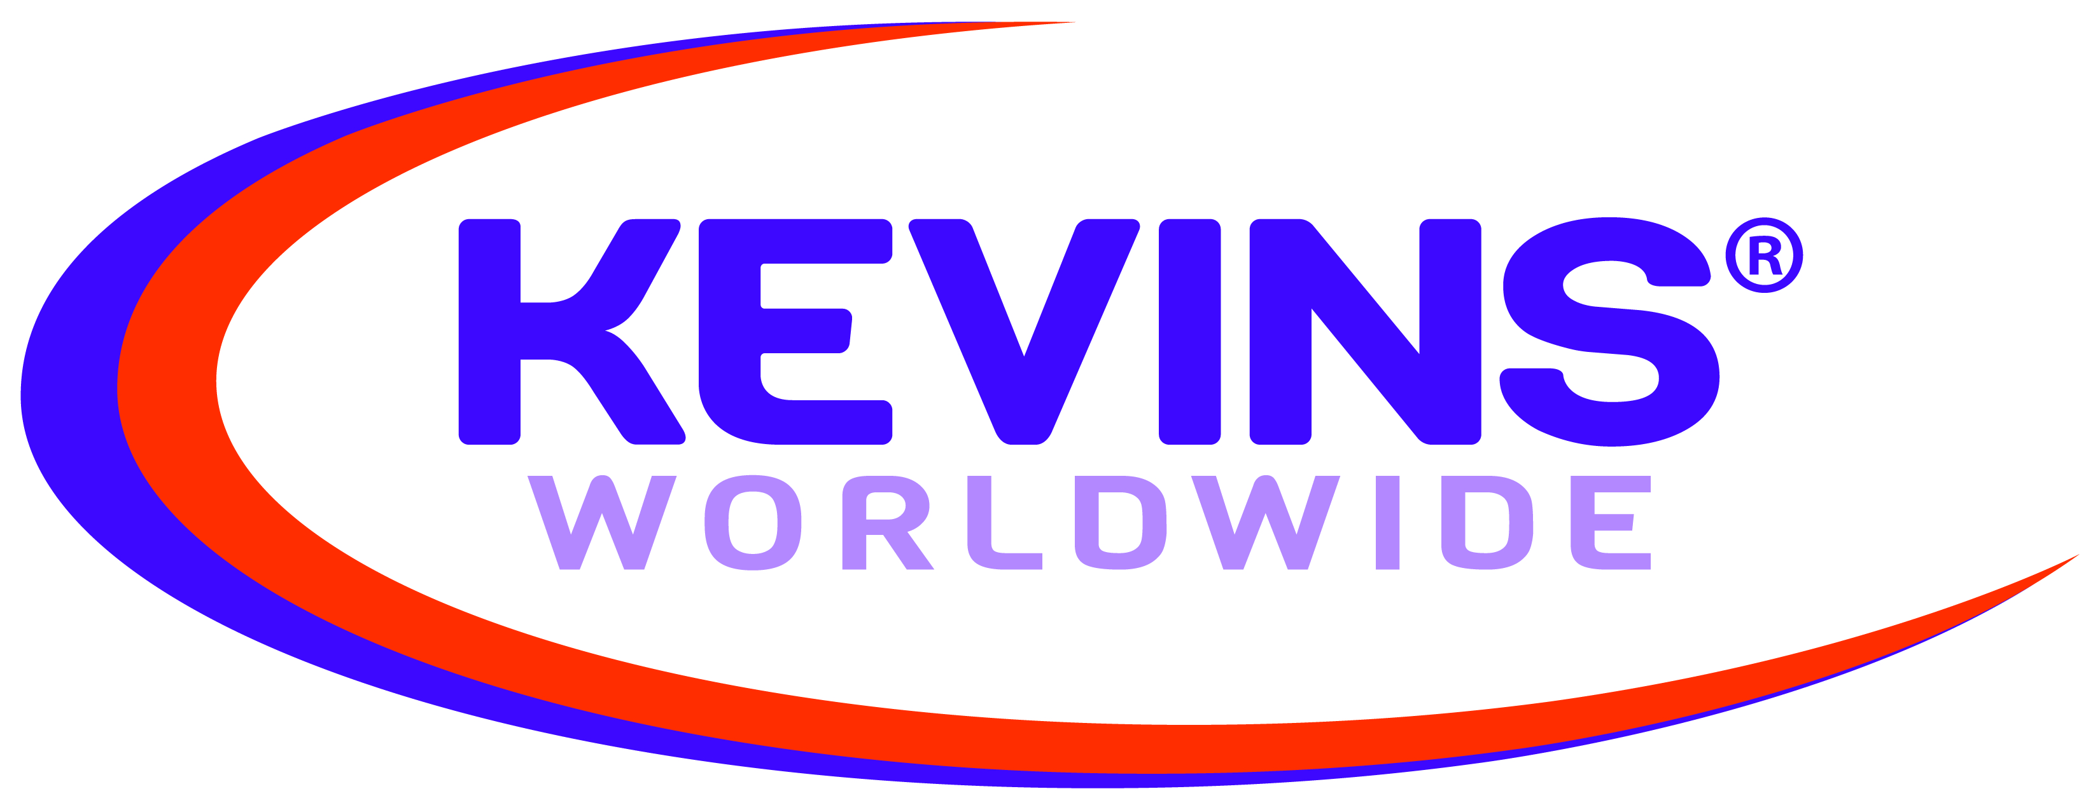 General Policy

ISSUE DATE: 3/24/2008 REVISED DATE: 6/12/2012

Product Safety and Quality

Kevins Worldwide is committed to applying the highest standards of safety and quality for its products. To meet the needs of clients and regulatory requirements of the markets we serve, Kevins will take all necessary steps to ensure that our products meet Federal product regulations and require our suppliers to obtain testing/documentation for their products.

Lead in Paint/Content

In compliance with the Consumer Product Safety Improvement Act, Kevins will assure acceptable levels of lead in paint or other similar surface coatings and content for all consumer products. The level in paint or other similar surface coatings must not contain a concentration of lead greater than 90 parts per million and the level in content must not contain a concentration of lead greater than 100 parts per million.

Polycarbonates and BPA

Kevins will only procure products made from polycarbonate material that meet the Food & Drug Administration’s regulations. The FDA banned the use of BPA-based polycarbonate resins in infant feeding bottles (baby bottles) and spill-proof cups (sippy cups) including their closures and lids. Kevins will not procure infant feeding bottles and spill-proof cups made from BPA-based polycarbonate resins.

California Proposition 65

Decorating and printing inks used on Kevins’ products that are decorated in the USA have been fully tested and do not contain chemicals at concentrations that would require a Proposition 65 warning label. Safe Harbor Level limits have not been fully established by Proposition 65 for all materials used in Kevin’s products, however we may be able to offer certification of independently tested concentrations of specific chemicals for specific products.

